ABC’s Inventory Management System

Manage Staff (Add Staff) Test Scripts

Table of Contents

AST001- Enter all details accurately to add a new staff 3

Data Set 1 3

Result Screenshots: 4

AST002- Enter all details accurately but enter a username that already exists 7

Data Set 1 7

Result Screenshots: 8

AST003- Add staff without entering all data 12

Data Set 1 12

Result Screenshots: 13

AST004- Add staff entering all details but passwords that do not match 16

Data Set 1 17

Result Screenshots: 17

AST005- Test Clear Data button 21

Data Set 1 21

Result Screenshots: 21

# AST001- Enter all details accurately to add a new staff

|  |  |  |  |  |  |
| --- | --- | --- | --- | --- | --- |
| **Test Name** | | Test enter all details accurately to add a new staff (Test AST001) | | | |
| **Use Case Tested** | | Manage Staff | | | |
| **Test Description** | | This test tests if the system can add a new staff who can access the system by entering all required data accurately. | | | |
| **Pre-Conditions** | | Users need be logged in as a Warehouse Staff (Warehouse Staff Access) in the Manage Staff page  Meta data to store Staff details in the database must exist. | | | |
| **Post-Conditions** | | A new Staff is added to the system. | | | |
| **Result (Pass/Fail/Warning/ Incomplete)** | | Pass | | | |
|  | **Test Step** | | **Expected Test Results** | **P** | **F** |
| 1. | Click on ‘Add Staff’ icon at ‘Manage Staff’ | | System prompts user to enter new staff details. | P |  |
| 2. | Enter all required data accurately. | | System waits for user to click on the ‘Add Staff (Tick)’ icon. | P |  |
| 3. | Click on ‘Add Staff’ icon. | | The system adds the staff details to the database, displays an appropriate message and displays the ‘Manage Staff’ Page. | P |  |

## Data Set 1

|  |  |
| --- | --- |
| **Data Set 1** | |
| **Fields** | **Values** |
| **First Name** | Ron |
| **Last Name** | A |
| **Email Address** | rona@email.com |
| **Phone** | 123456 |
| **Address** | 23 Ron Street, Ron, NSW 1000 |
| **Date of Birth** | 21/07/1989 |
| **Username** | ron |
| **Password** | ron |
| **Confirm Password** | ron |
| **Base Location** | Newtown Warehouse |

### Result Screenshots:

**Step 1**

After clicking on ‘Add Staff’ Icon at ‘Manage Staff’ system prompts user to enter new staff details

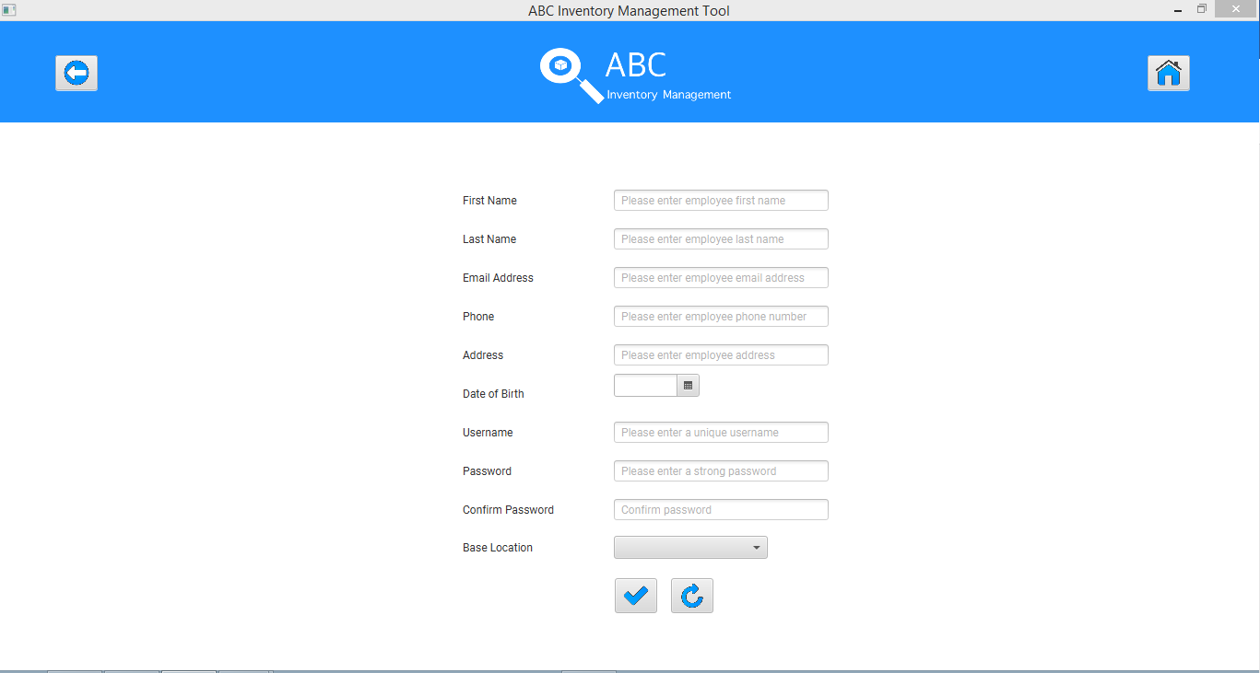

**Step 2**

User enters all required data.

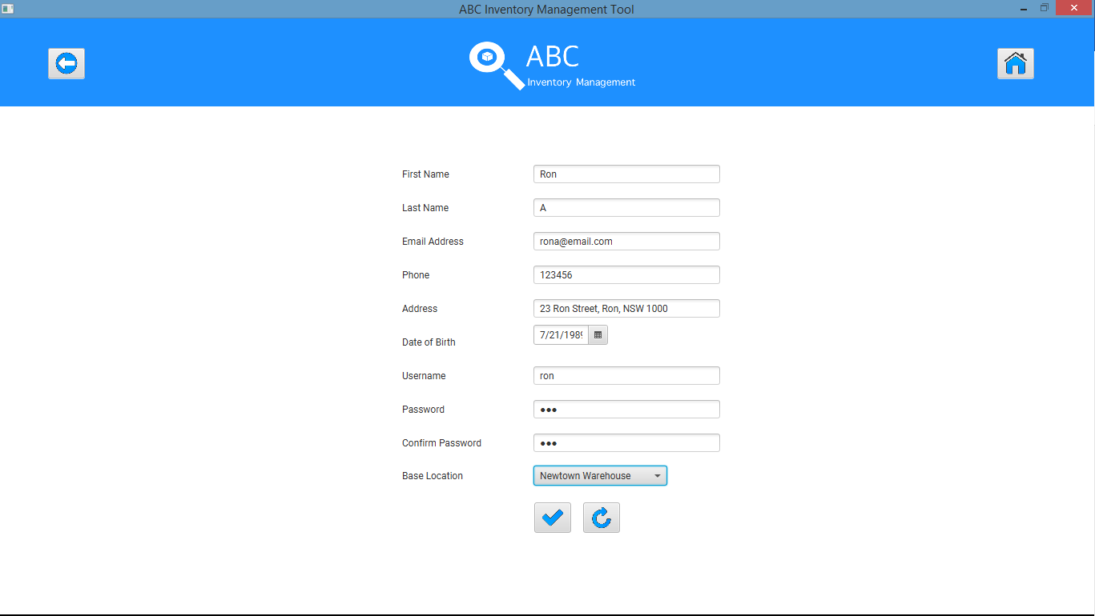

**Step 3**

System displays an appropriate message

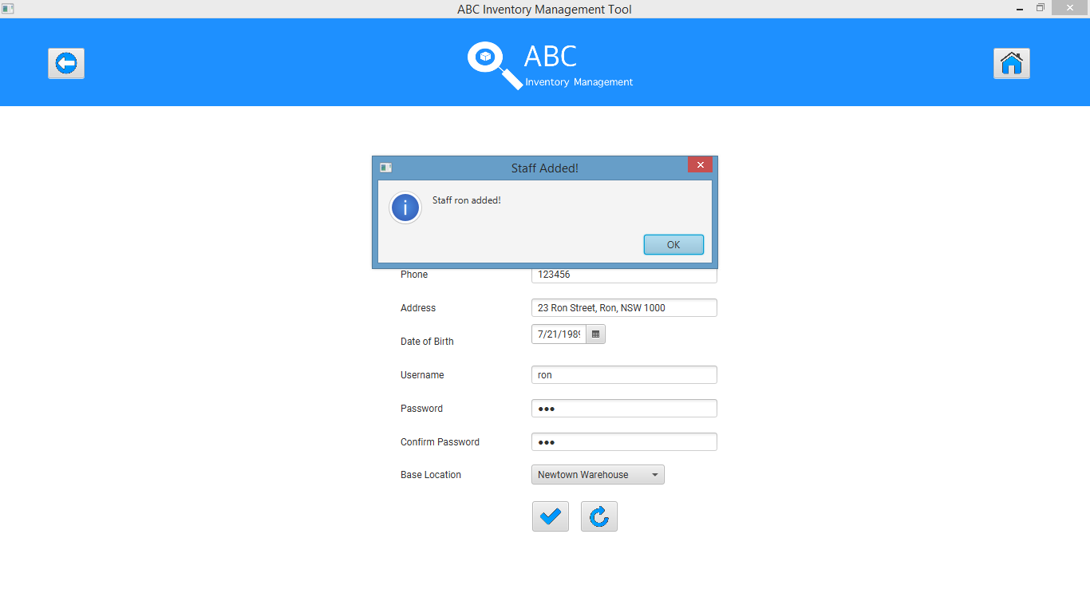

System displays ‘Manage Staff’ with the newly added staff having username ‘ron’

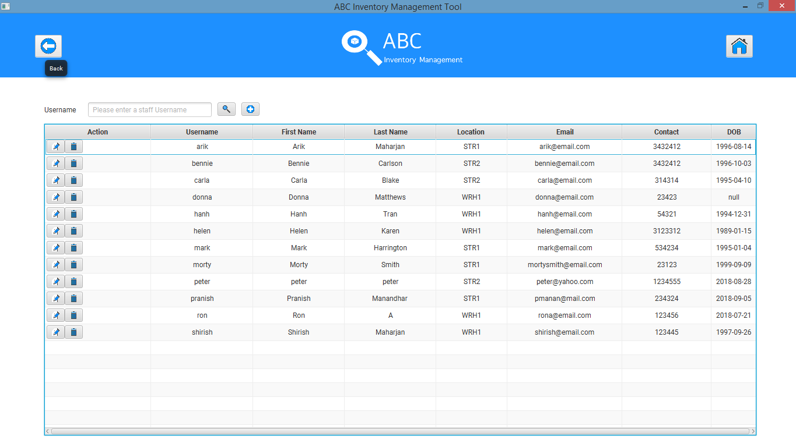

# AST002- Enter all details accurately but enter a username that already exists

|  |  |  |  |  |  |
| --- | --- | --- | --- | --- | --- |
| **Test Name** | | Test enter all details accurately but enter a username that already exists (AST002) | | | |
| **Use Case Tested** | | Manage Staff | | | |
| **Test Description** | | This test tests how the system reacts when the user enters an existing username while adding a new staff. | | | |
| **Pre-Conditions** | | Users need be logged in as a Warehouse Staff (Warehouse Staff Access) in the Manage Staff page  Meta data to store Staff details in the database must exist. | | | |
| **Post-Conditions** | | No staff is added to the system and an appropriate error message is displayed. | | | |
| **Result (Pass/Fail/Warning/ Incomplete)** | | Pass | | | |
|  | **Test Step** | | **Expected Test Results** | **P** | **F** |
| 1. | Click on ‘Add Staff’ icon at ‘Manage Staff’ | | System prompts user to enter new staff details. | P |  |
| 2. | Enter all required data accurately but put in a username that already exists. | | System waits for user to click on the ‘Add Staff (Tick)’ icon. | P |  |
| 3. | Click on ‘Add Staff’ icon. | | System displays an appropriate message and prompts user to enter a unique username. | P |  |
| 4. |  | | System clears the username field for the user to enter a unique username. | P |  |
| 5. | Enter a unique username and click on ‘Add Staff’ icon. | | The system adds the staff details to the database, displays an appropriate message and displays the ‘Manage Staff’ Page. | P |  |

## Data Set 1

|  |  |
| --- | --- |
| **Data Set 1** | |
| **Fields** | **Values** |
| **First Name** | Ronnie |
| **Last Name** | B |
| **Email Address** | ronnieb@email.com |
| **Phone** | 123457 |
| **Address** | 23 Ronnie Street, Ronnie, NSW 2001 |
| **Date of Birth** | 31/08/1995 |
| **Username** | Ron followed by ronnie |
| **Password** | ronnie |
| **Confirm Password** | ronnie |
| **Base Location** | Epping Store |

### Result Screenshots:

**Step 1**

After clicking on ‘Add Staff’ Icon at ‘Manage Staff’ system prompts user to enter new staff details



**Step 2**

Enter all required data. Set username as ron which already exists.

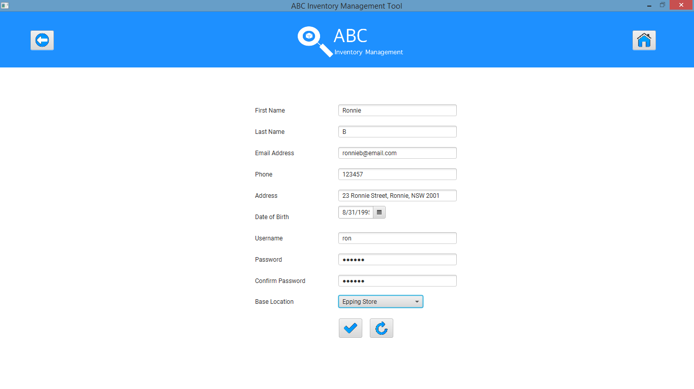

**Step 3**

Click on ‘Add Staff’ icon after which the system displays an appropriate message as shown in the screenshot below.

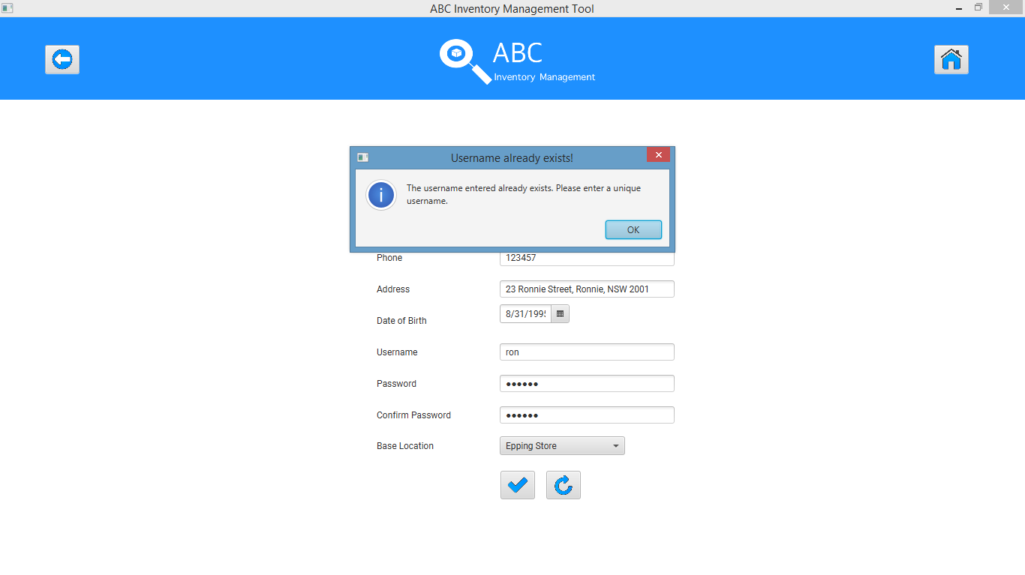

**Step 4**

The username field is cleared for user to re enter a unique username.

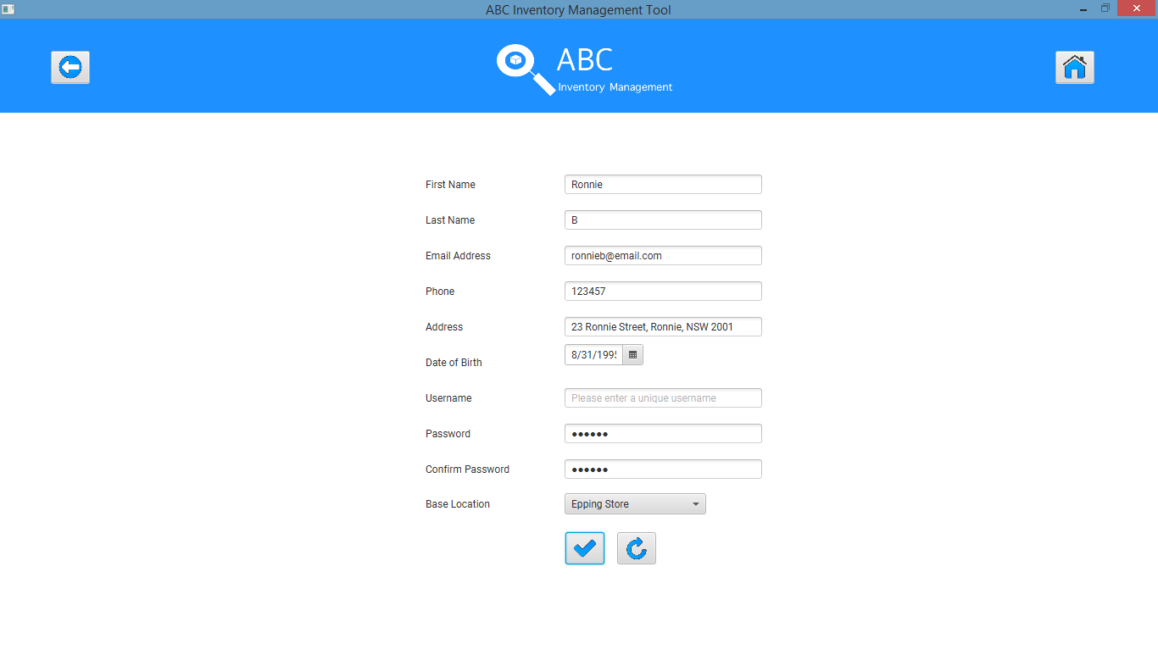

**Step 5**

User enters a unique username and clicks on ‘Add Staff’ icon.

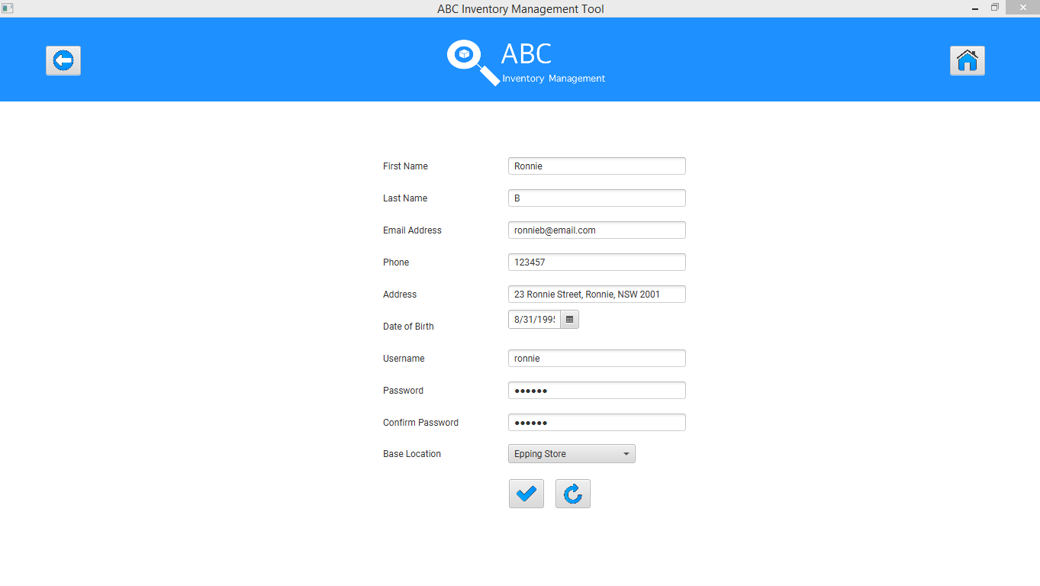

System displays an appropriate message

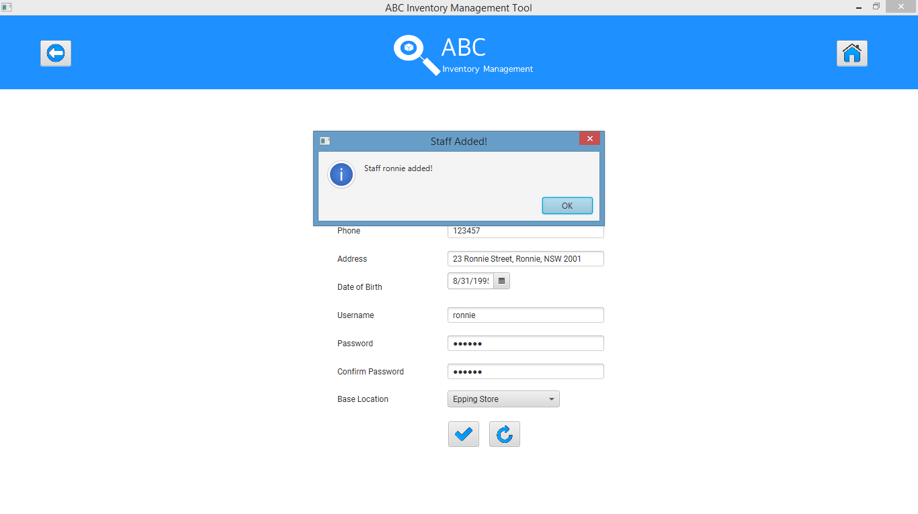

# AST003- Add staff without entering all data

|  |  |  |  |  |  |
| --- | --- | --- | --- | --- | --- |
| **Test Name** | | Test add staff without entering all data (AST003) | | | |
| **Use Case Tested** | | Manage Staff | | | |
| **Test Description** | | This test tests how the system reacts when the user tries to add a new staff without entering all data | | | |
| **Pre-Conditions** | | Users need be logged in as a Warehouse Staff (Warehouse Staff Access) in the Manage Staff page | | | |
| **Post-Conditions** | | No staff is added to the system, an appropriate error message is displayed and all data fields that are required to be filled in is highlighted. | | | |
| **Result (Pass/Fail/Warning/ Incomplete)** | | Pass | | | |
|  | **Test Step** | | **Expected Test Results** | **P** | **F** |
| 1. | Click on ‘Add Staff’ icon at ‘Manage Staff’ | | System prompts user to enter new staff details. | P |  |
| 2. | Enter data accurately but leave a few fields empty. | | System waits for user to click on the ‘Add Staff (Tick)’ icon. | P |  |
| 3. | Click on ‘Add Staff’ icon. | | System displays an appropriate message and prompts user to enter all required data. | P |  |
| 4. |  | | System highlights all fields that are required to be filled. | P |  |
| 5. | Enter all details that are required and highlighted by the system. | | The system adds the staff details to the database, displays an appropriate message and displays the ‘Manage Staff’ Page. | P |  |

## Data Set 1

|  |  |
| --- | --- |
| **Data Set 1** | |
| **Fields** | **Values** |
| **First Name** | Derek |
| **Last Name** | A |
| **Email Address** | (empty) |
| **Phone** | 1234576 |
| **Address** | 23 Derek Street, Derek, NSW 2002 |
| **Date of Birth** | 02/12/1991 |
| **Username** | (empty) |
| **Password** | derek |
| **Confirm Password** | (empty) |
| **Base Location** | Oxford Store |

### Result Screenshots:

**Step 1**

After clicking on ‘Add Staff’ Icon at ‘Manage Staff’ system prompts user to enter new staff details



**Step 2**

Enter all fields except email address, username and confirm password field.

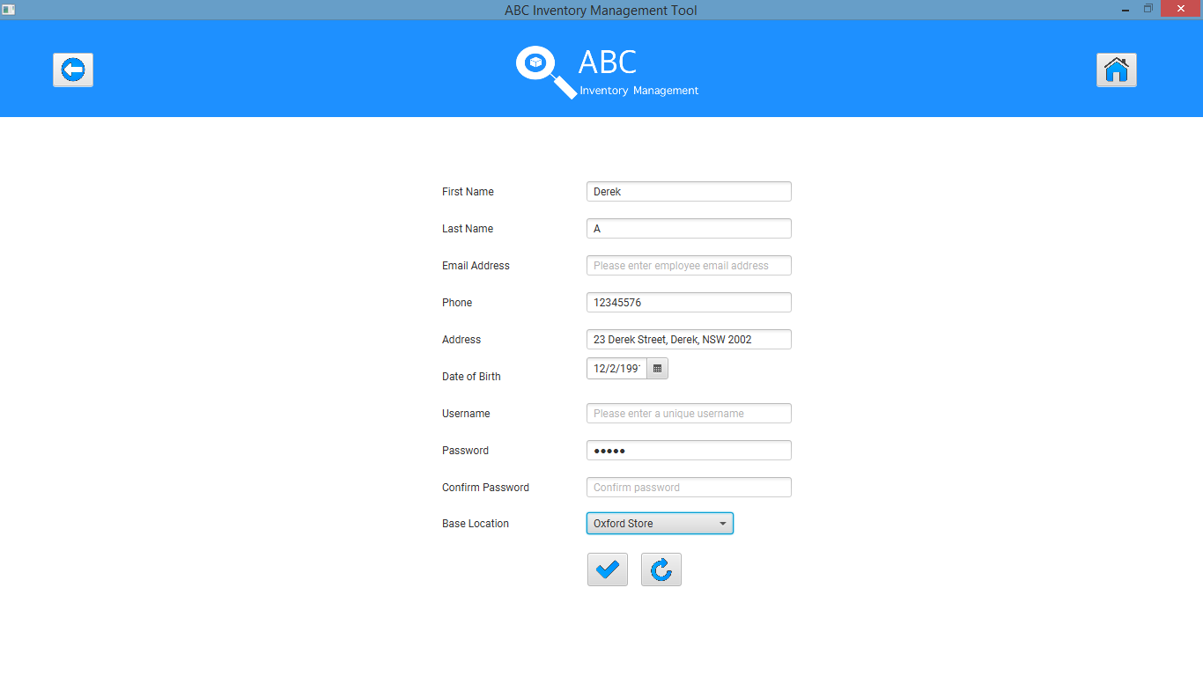

**Step 3**

Click on ‘Add Staff’ icon after which the system displays an appropriate message as shown in the screenshot below.

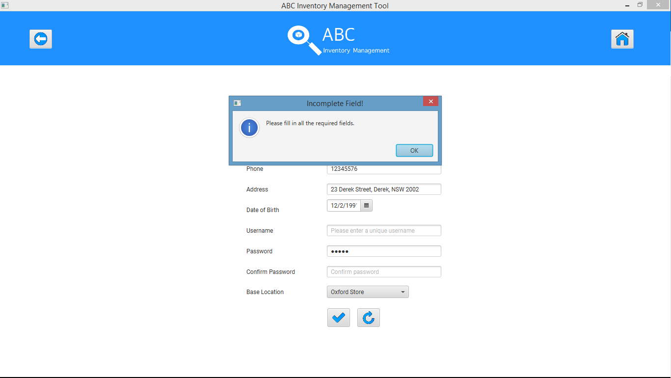

**Step 4**

System highlights and prompts user to fill necessary fields.

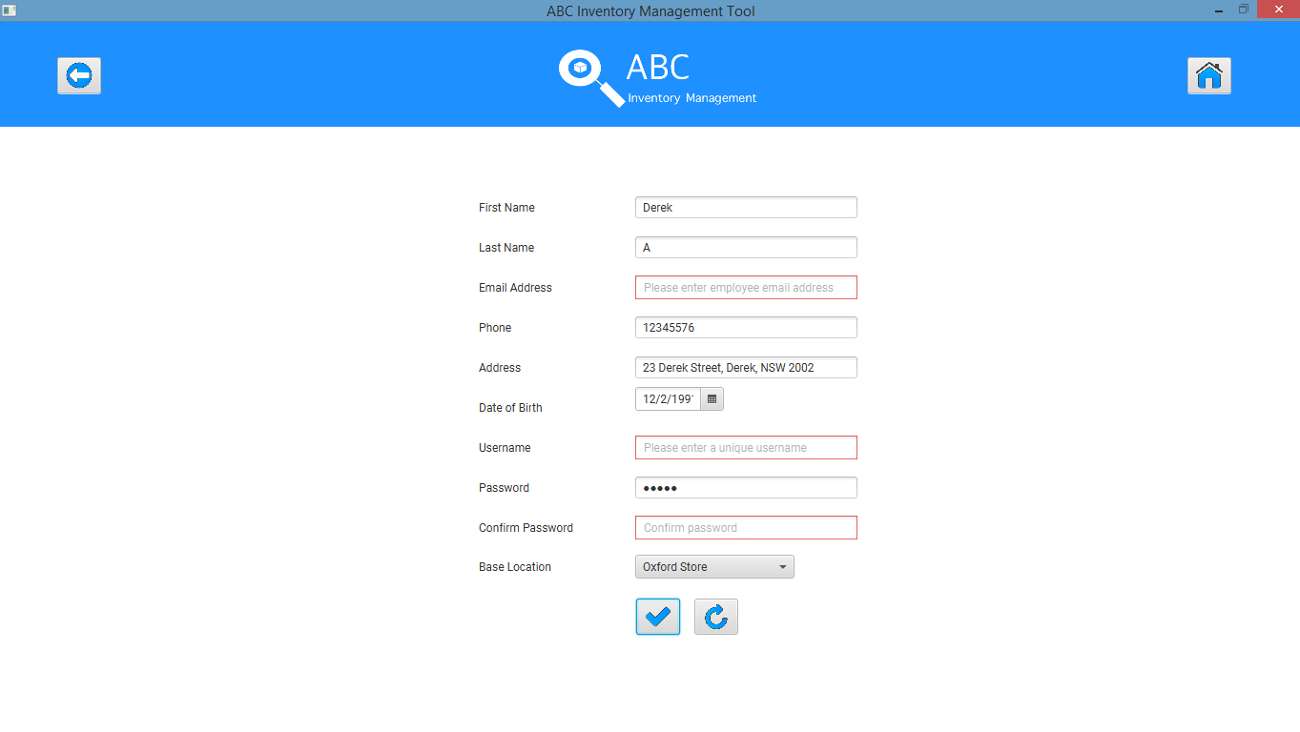

**Step 5**

User enters all required Data.

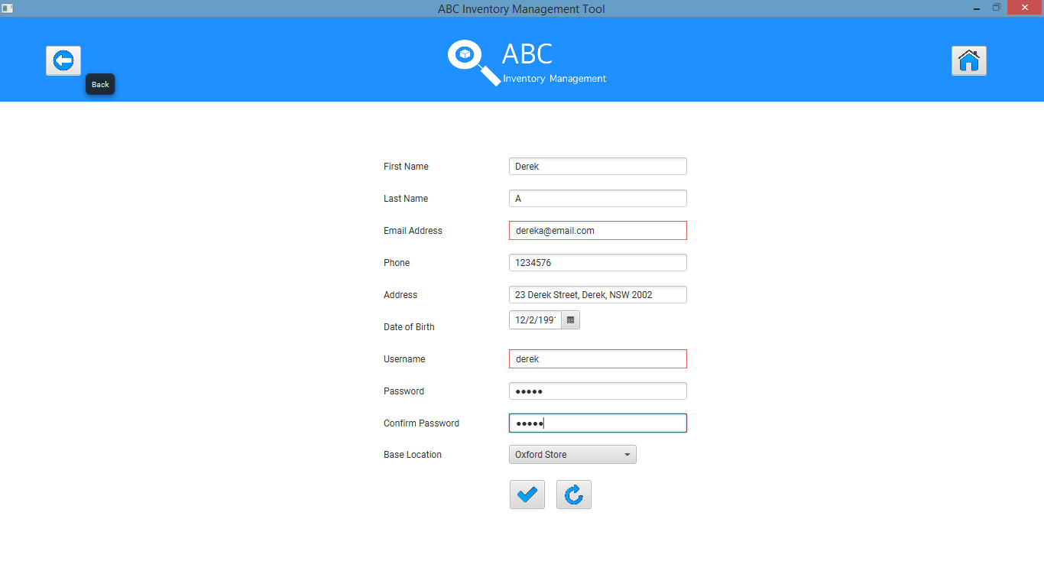

System displays an appropriate message

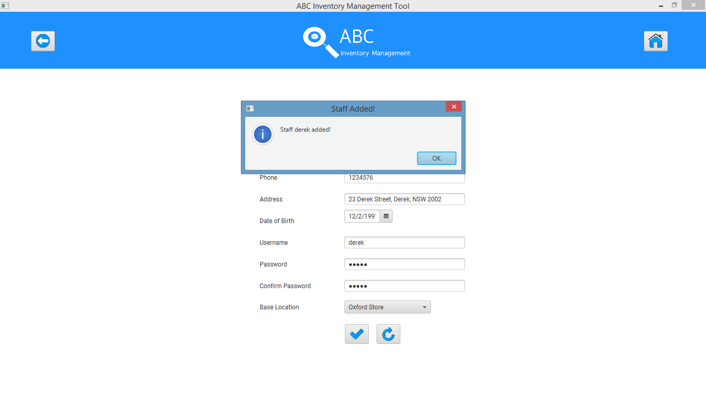

# AST004- Add staff entering all details but passwords that do not match

|  |  |  |  |  |  |
| --- | --- | --- | --- | --- | --- |
| **Test Name** | | Test add staff entering all details but passwords that do not match (AST004) | | | |
| **Use Case Tested** | | Manage Staff | | | |
| **Test Description** | | This test tests how the system reacts when the user tries to add a new staff when passwords do not match | | | |
| **Pre-Conditions** | | Users need be logged in as a Warehouse Staff (Warehouse Staff Access) in the Manage Staff page | | | |
| **Post-Conditions** | | No staff is added to the system, an appropriate error message is displayed, and Password and Confirm Password fields are cleared and highlighted. | | | |
| **Result (Pass/Fail/Warning/ Incomplete)** | | Pass | | | |
|  | **Test Step** | | **Expected Test Results** | **P** | **F** |
| 1. | Click on ‘Add Staff’ icon at ‘Manage Staff’. | | System prompts user to enter new staff details. | P |  |
| 2. | Enter all required data accurately but enter passwords that do not match. | | System waits for user to click on the ‘Add Staff (Tick)’ icon. | P |  |
| 3. | Click on ‘Add Staff’ icon. | | System displays an appropriate message and prompts user to enter matching passwords. | P |  |
| 4. |  | | System clears and highlights the ‘Password’ and ‘Confirm Password’ fields. | P |  |
| 5. | Enter matching passwords and click on ‘Add Staff’ icon. | | The system adds the staff details to the database, displays an appropriate message and displays the ‘Manage Staff’ Page. | P |  |

## Data Set 1

|  |  |
| --- | --- |
| **Data Set 1** | |
| **Fields** | **Values** |
| **First Name** | Bailey |
| **Last Name** | A |
| **Email Address** | bailey@email.com |
| **Phone** | 654321 |
| **Address** | 21, Bailey Street, Bails, NSW 2003 |
| **Date of Birth** | 08/10/1979 |
| **Username** | bailey |
| **Password** | bailey |
| **Confirm Password** | bailei |
| **Base Location** | Newtown Warehouse |

### Result Screenshots:

**Step 1**

After clicking on ‘Add Staff’ Icon at ‘Manage Staff’ system prompts user to enter new staff details



**Step 2**

Enter all required values but enter different values for password and confirm password fields.

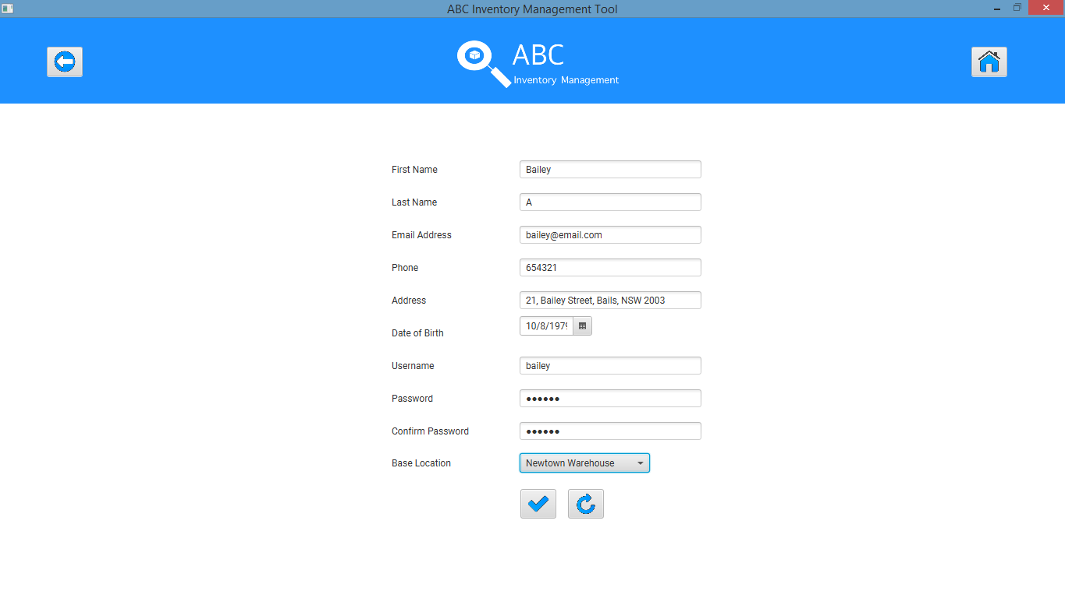

**Step 3**

Click on ‘Add Staff’ icon after which the system displays an appropriate message.

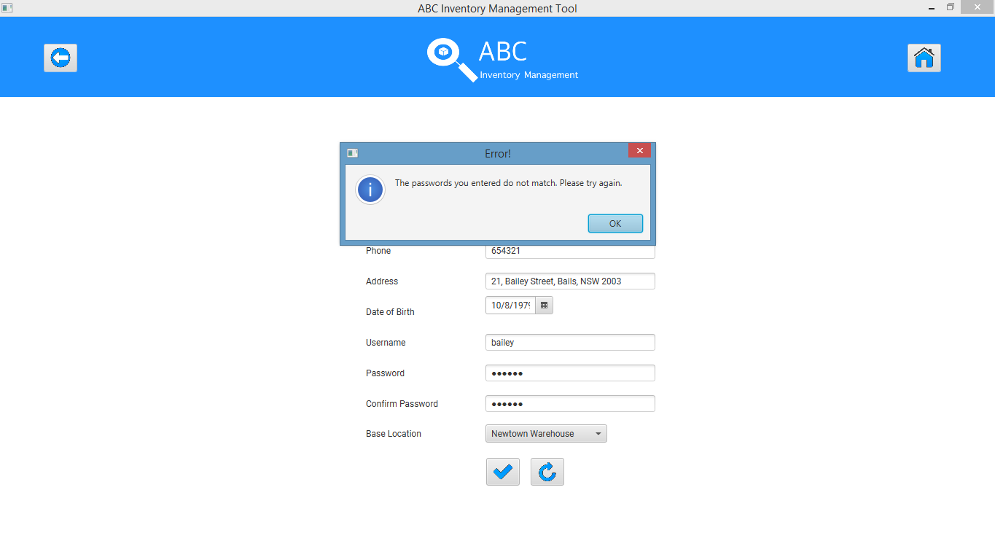

**Step 4**

The system highlights and clears the password and confirm password fields and prompts the user to fill those fields.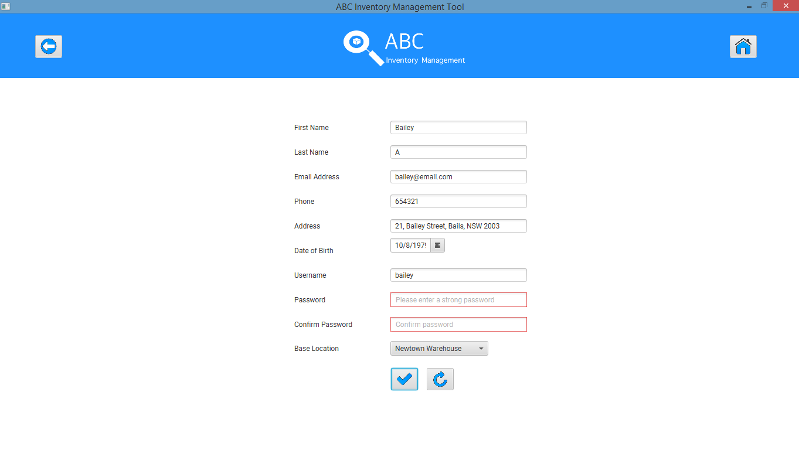

**Step 5**

User enters matching passwords

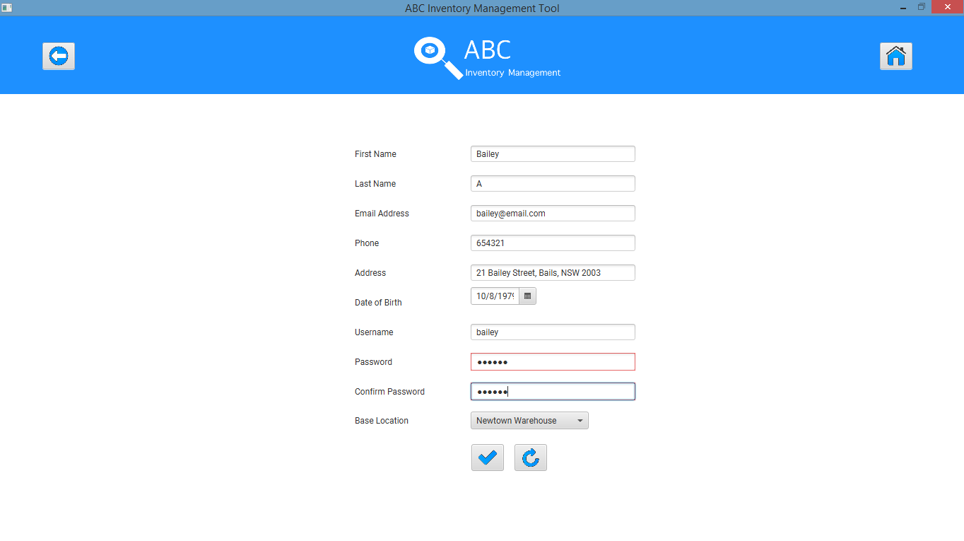

System displays an appropriate message

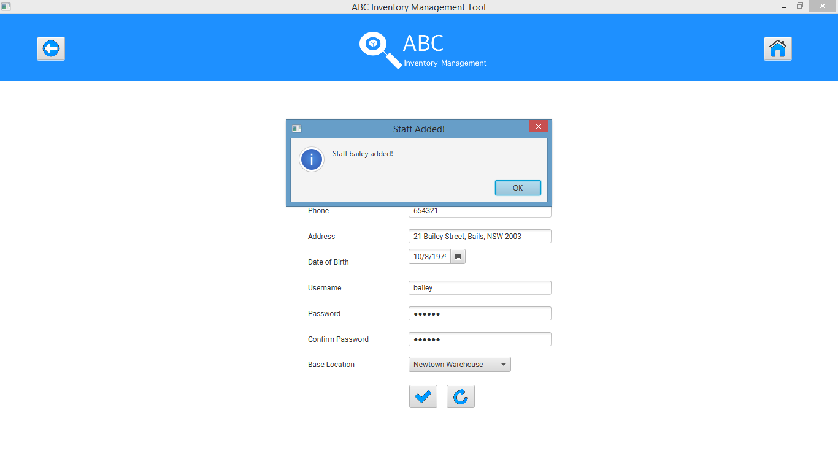

# AST005- Test Clear Data button

|  |  |  |  |  |  |
| --- | --- | --- | --- | --- | --- |
| **Test Name** | | Test Clear Data button (AST005) | | | |
| **Use Case Tested** | | Manage Staff | | | |
| **Test Description** | | This test tests how the system reacts when the user clicks on the ‘Clear Text’ icon. | | | |
| **Pre-Conditions** | | Users need be logged in as a Warehouse Staff (Warehouse Staff Access) in the Manage Staff page | | | |
| **Post-Conditions** | | No staff is added to the system and the system clear all fields for the user to enter. | | | |
| **Result (Pass/Fail/Warning/ Incomplete)** | | Pass | | | |
|  | **Test Step** | | **Expected Test Results** | **P** | **F** |
| 1. | Click on ‘Add Staff’ icon at ‘Manage Staff’. | | System prompts user to enter new staff details. | P |  |
| 2. | Enter all required data accurately. | | System waits for user to click on the ‘Add Staff (Tick)’ or ‘Clear Text’ icon. | P |  |
| 3. | Click on ‘Clear Text’ icon. | | System clears all fields and waits for the user to enter all fields. | P |  |

## Data Set 1

|  |  |
| --- | --- |
| **Data Set 1** | |
| **Fields** | **Values** |
| **First Name** | Ron |
| **Last Name** | A |
| **Email Address** | rona@email.com |
| **Phone** | 123456 |
| **Address** | 23 Ron Street, Ron, NSW 1000 |
| **Date of Birth** | 21/07/1989 |
| **Username** | ron |
| **Password** | ron |
| **Confirm Password** | ron |
| **Base Location** | Newtown Warehouse |

### Result Screenshots:

**Step 1**

After clicking on ‘Add Staff’ Icon at ‘Manage Staff’ system prompts user to enter new staff details



**Step 2**

User enters all required data and clicks on ‘Clear Text’ icon.



**Step 3**

System clears all fields and waits for user to enter data

